**Document Control**

Document Information

|  |  |
| --- | --- |
| **©** | **Information** |
| Document Id | *FSPM - 01* |
| Document Owner | *MUHAMMAD UMER* |
| Issue Date | *24/11/2023* |
| Last Saved Date | *24/11/2023* |
| File Name | *PROJECT PLAN* |

Document Approvals

|  |  |  |  |
| --- | --- | --- | --- |
| **Role** | **Name** | **Signature©** | **Date** |
| Project Sponsor | FAST NUCES |  |  |
| Project Review Group | SAAD KHAN  AHMED HAMZA |  |  |
| Project Manager | MUHAMMAD UMER |  |  |
| Quality Manager  *(if applicable)* | SAAD KHAN |  |  |

**Table of Contents**

Template Guide 1

1 Planning Basis 2

1.1 Scope 2

1.2 Milestones 2

1.3 Phases 2

1.4 Tasks 3

1.5 Effort 3

1.6 Resources 4

2 Project Plan 4

2.1 Schedule 4

2.2 Dependencies 5

2.3 Assumptions 5

2.4 Constraints 5

3 Project Budget, Risk Log and Change Management 6

3.1 Project Budget 6

3.2 Risk Log 6

3.3 Change Management 6

4 Appendix 7

# 

# Planning Basis

## Scope

The final product of this project will result in the design, development, and deployment of a mobile application tailored for the agricultural sector. The app will focus on crop identification, disease detection, and pesticide recommendations, along with features for community engagement. The project will adhere to data privacy regulations and ensure compatibility with various mobile devices. Continuous improvement and adaptability are inherent aspects of the project's scope to address the dynamic nature of the agricultural landscape.

## Milestones

The project Summary Milestone Schedule is presented below. As if the requirements changed this schedule may also changes. Any changes will be communicated through project status meetings by the project manager.

|  |  |
| --- | --- |
| Project Milestone | Target Date |
| Project Start | 01/11/2023 |
| Complete Plan of the Project | 01/12/2023 |
| Acquire all the resources | 15/12/2023 |
| Complete Mobile App Design with Simulation | 30/01/2024 |
| Deployment and Debugging | 15/02/2024 |
| Maintenance | 05/04/2024 |
| Project Complete | 05/05/2024 |

* Feasibility Study: We will have feasibility study approved by the project owner by end of September, 2023.
* Project Charter: We have the project charter written by Mr Ahemad Hamza and reviewed by Mohammad Umar and Saad Khan.
* Project Team appointed: The team has successfully been allocated to the project.  There are 5 members in the UI team and 7 members for the backend development. there are three members for the database and its configuration.  The Quality Assurance team has two members.

List and describe the key project milestones within the following table:

|  |  |  |
| --- | --- | --- |
| **Milestone** | **Description** | **Delivery Date** |
| Business Case Approved. | The Business Case has been documented and was approved by the Project Sponsor, Meezan Oil Industries | 20/10/2023 |
| Project Charter | Project was written by Ahmed Hamza  and was approved by Saad Khan. | 20/10/2023 |
| Project Team appointed | Project teams were successfully assigned to the project. 20th September for the UI, 25th September for database, and 30th September for the back and development | 30/10/2023 |

## Tasks

A ‘*task*’ is simply an item of work to be completed within the project. List all tasks required to undertake each activity, within the following table:

|  |  |
| --- | --- |
| **Phase** | **Task** |
| **Initiation Phase** | * Define the project scope, objectives, and purpose. * Identify stakeholders and establish communication channels. * Conduct a feasibility study and risk assessment. * Develop a project charter. |
| **Planning Phase** | * Create a detailed project plan, including timelines, milestones, and deliverables. * Define roles and responsibilities of team members. * Identify and allocate resources (human, financial, and materials). * Develop a risk management plan. * Create a communication plan. * Establish a change control process. * Develop a budget. * Conduct a kick-off meeting |
| **Execution Phase** | * + Implement the project plan.   + Manage and coordinate project resources.   + Communicate with stakeholders.   + Monitor and control project work.   + Address and resolve issues and risks.   + Collect and analyze project performance data.   + Implement approved changes.   + Ensure quality control. |
| **Monitoring and Controlling Phase** | * Track project performance against the project plan. * Monitor and control project scope, schedule, and costs. * Manage changes to the project scope. * Ensure quality standards are met. * Conduct regular status meetings. * Manage risks and issues. * Review and approve deliverables. |
| **Closing Phase** | * Obtain customer or stakeholder acceptance. * Complete and archive project documentation. * Release project resources. * Conduct a project review or post-implementation review. * Obtain formal project closure, including financial closure. * Celebrate project success and lessons learned. |

# Project Plan

## Schedule

This section shows a summarised schedule for each of the phases and activities within the project.

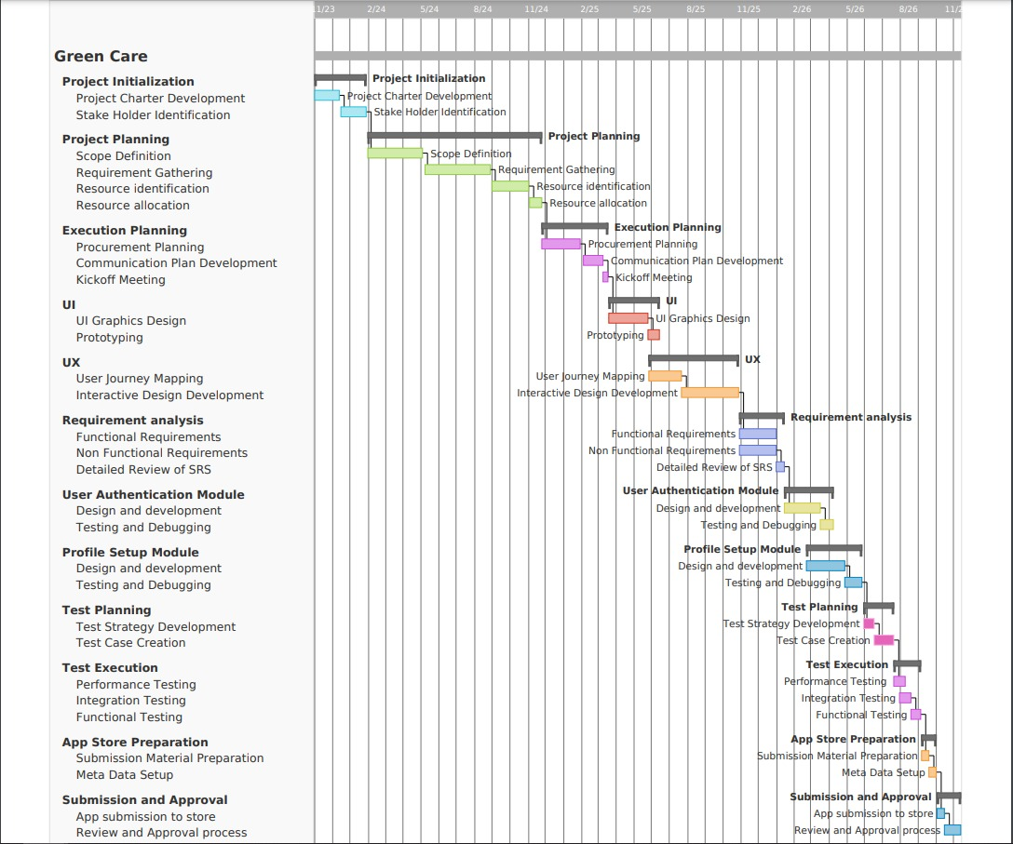

## Dependencies

Although each activity is being started upon finishing up of its previous activity in Gantt chart, however there are still two activities which depends upon some certain activities which is described below:

|  |  |  |
| --- | --- | --- |
| **Activity** | **Depends on©** | **Dependency Type** |
| Integration Testing | Performance Testing | Semi – Start to Start |
| Functional Requirements | Non -Functional Requirements | Start to Start |
| Rest of The Activities | Rest of The Activities | Finish to Start |

## Assumptions

* The project will not change in scope
* The resources identified will be available upon request
* Approved funding will be available upon request.

## Constraints

* The project must operate within the funding and resource allocations approved
* The project team must deliver the software with no requirement for additional hardware
* Staff must complete the project within normal working hours.

# Budget, Risks and Change Management

**3.1 Project Budget**

Following are the summary of the budget:

|  |  |  |  |
| --- | --- | --- | --- |
| WBS | Task | Labor | Materials |
| 1 | Initiation | $1000 | $200 |
|  | Planning | $2500 |  |
|  | Execution | $2000 |  |
| 2 | UI | $ 3000 | $200 |
|  | UX | $4500 | $600 |
| 3 | Requirement analysis | $2000 |  |
|  | User module | $2000 |  |
|  | Profile setup module | $10000 | $1500 |
| 4 | Planning | $5000 |  |
|  | Execution | $15000 | $2000 |
| 5 | App store | $12000 | $3000 |
|  | Submission and approvals | $5000 | $2500 |

The final cose of the project would be $74000 out of which $10,000 is for materials required for the tasks and $64,000 is labor cost

**3.2 Risk Log**

The following risks may arise during the project creation.

|  |  |  |  |  |  |
| --- | --- | --- | --- | --- | --- |
| ID | Risk | Impact | Response | Risk Level | Risk Owner |
| 1 | Supply delay | Schedule | Backup Supplier | High | Daniel Johnson |
| 2 | Image classification accuracy | Schedule | Built-in CV models | High | Janson Bitchas |
| 3 | Integration failure | Cost | Azure premium subscriptions | Moderate | Jakson Analie |
| 4 | Data breach | Cost | Strong AWS Cloud private clouds | High | Hakiee jakie |
| 5 | Scalability | Scope | Dockers image optimisations | Low | Janiee Sulkim |

**3.3 Change Management**

When a change request is made, use this log to track its impact, response and whether the change control board has approved it or not.

| **Date** | **Change Description** | **Type** | **Start Date** | **End Date** |
| --- | --- | --- | --- | --- |
| 1/2/2024 | Add spackle | Schedule | 1/20/2023 | 1/30/2023 |
| 2/5/2024 | Update irrigation system | Scope | - | - |
| 3/15/2024 | Integrate weather API | Feature | 3/20/2023 | 3/25/2023 |
| 4/10/2024 | Revise user interface | Design | 4/15/2023 | 4/30/2023 |
| 5/1/2024 | Implement multi-language support | Feature | 5/5/2023 | 5/20/2023 |

# 

# Appendix

Attached are documentation the we believe is relevant to the Project Plan.

* Detailed Project Schedule (listing all project phases, activities and tasks)
* Other documentation (Business Case, Feasibility Study, Project Charter)
* Other relevant information or correspondence.